**Screen Shots for the project**

**Update** **of Project:**

**Multiple Guest Reservation in a single Room:**

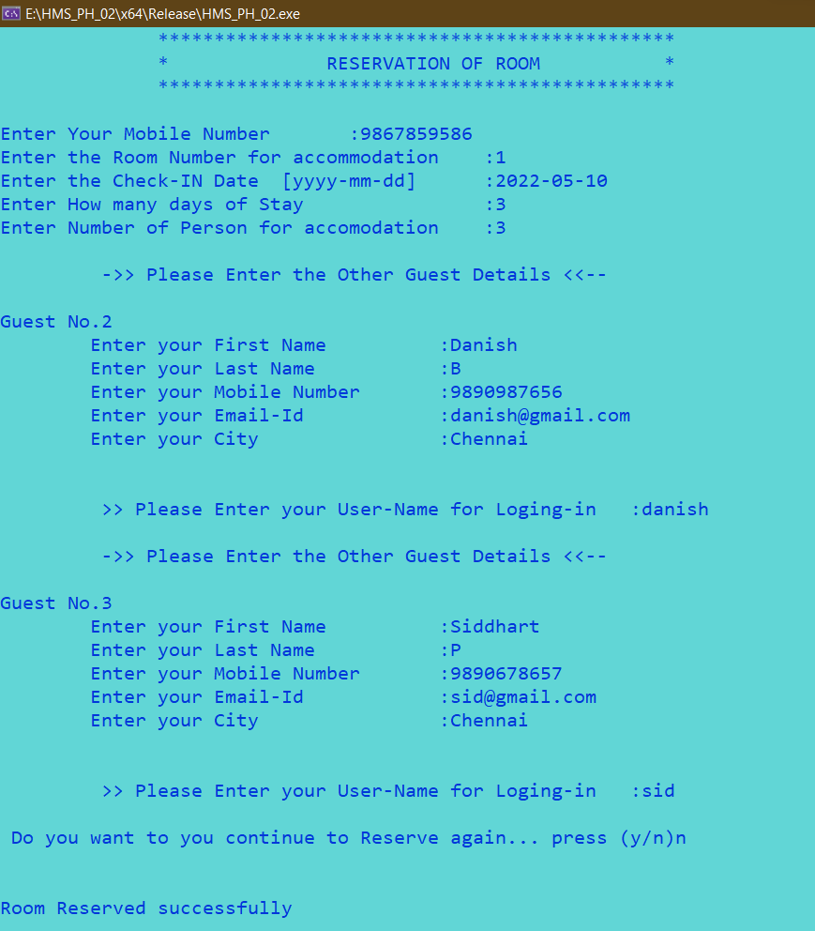

**In Guest Info Table:**



**Maximum Capacity Of Room:**

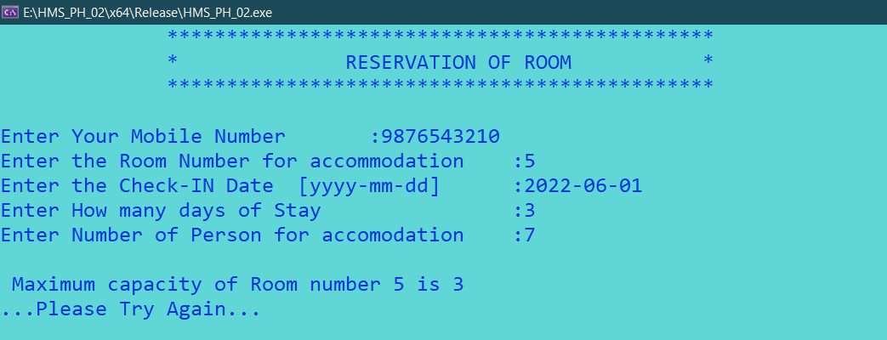

**Forgot Password Screen:**

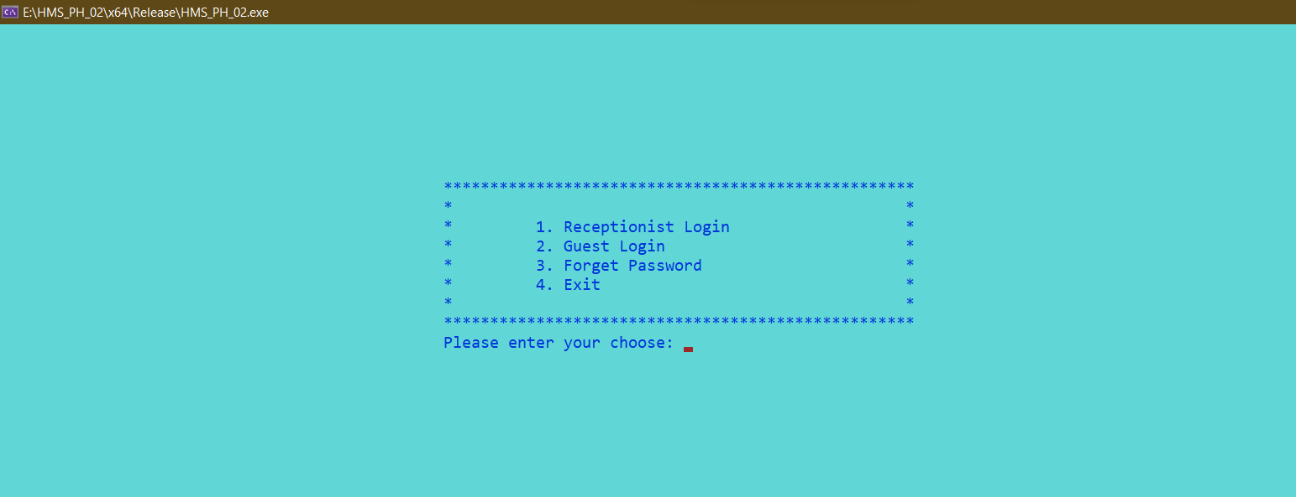

**Successful password change:**

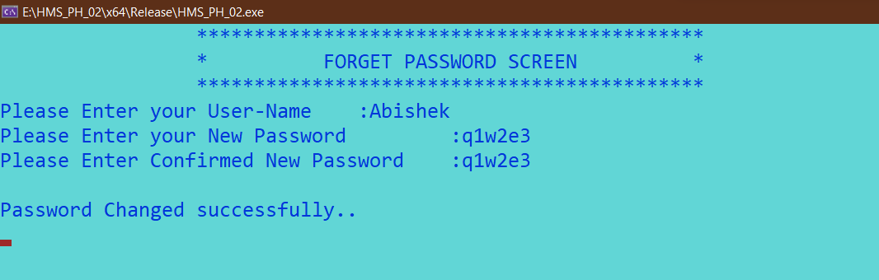

**Un-Successful password change:**

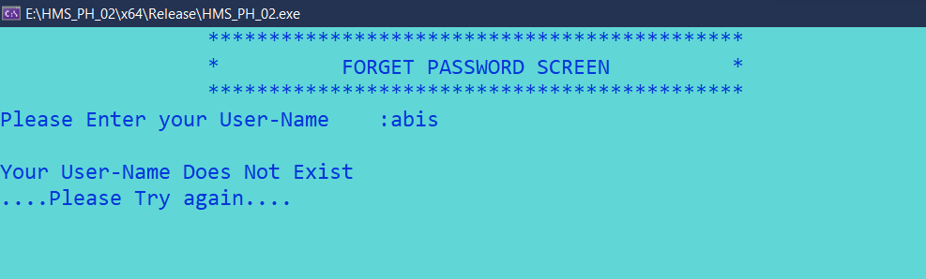

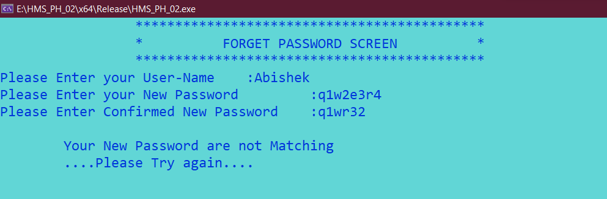

**PREVIOUS UPDATION**

**Login Credentials Table:**

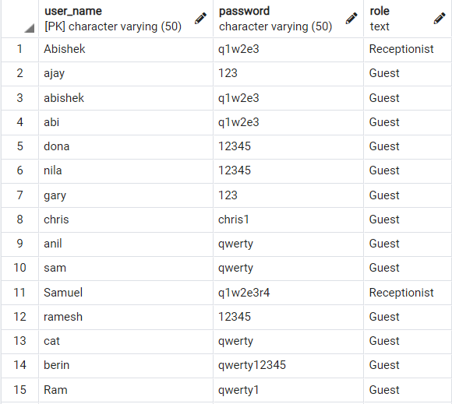

**Guest Info Table:**

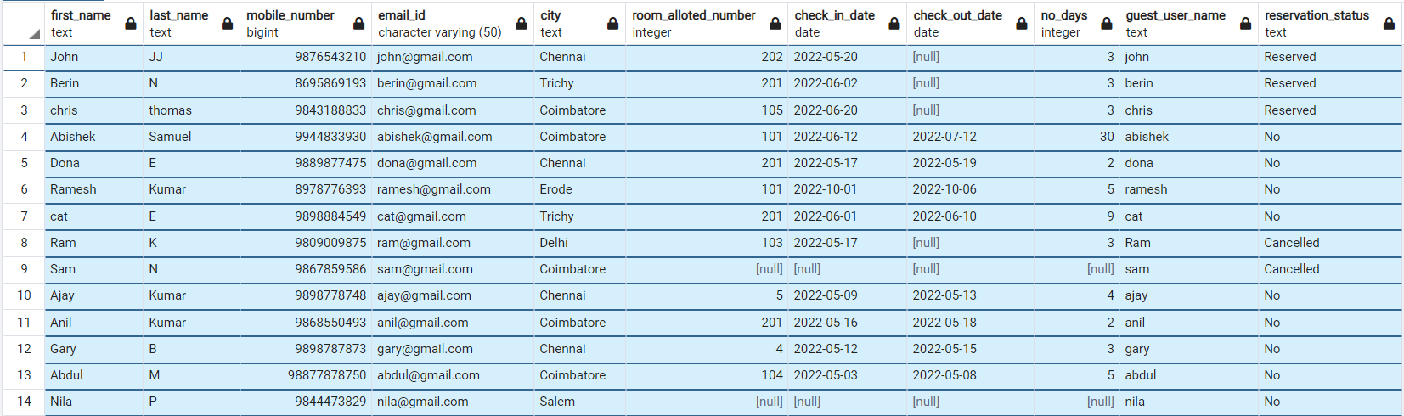

**Guest Details When Logged-In:**

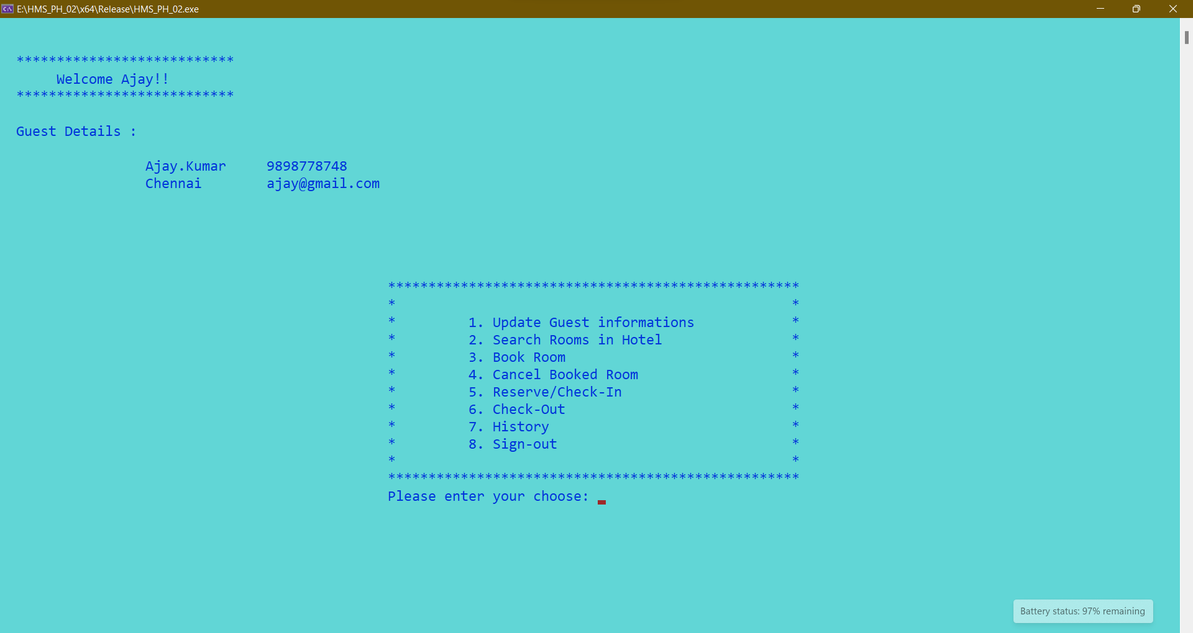

**Room Booking Screen:**

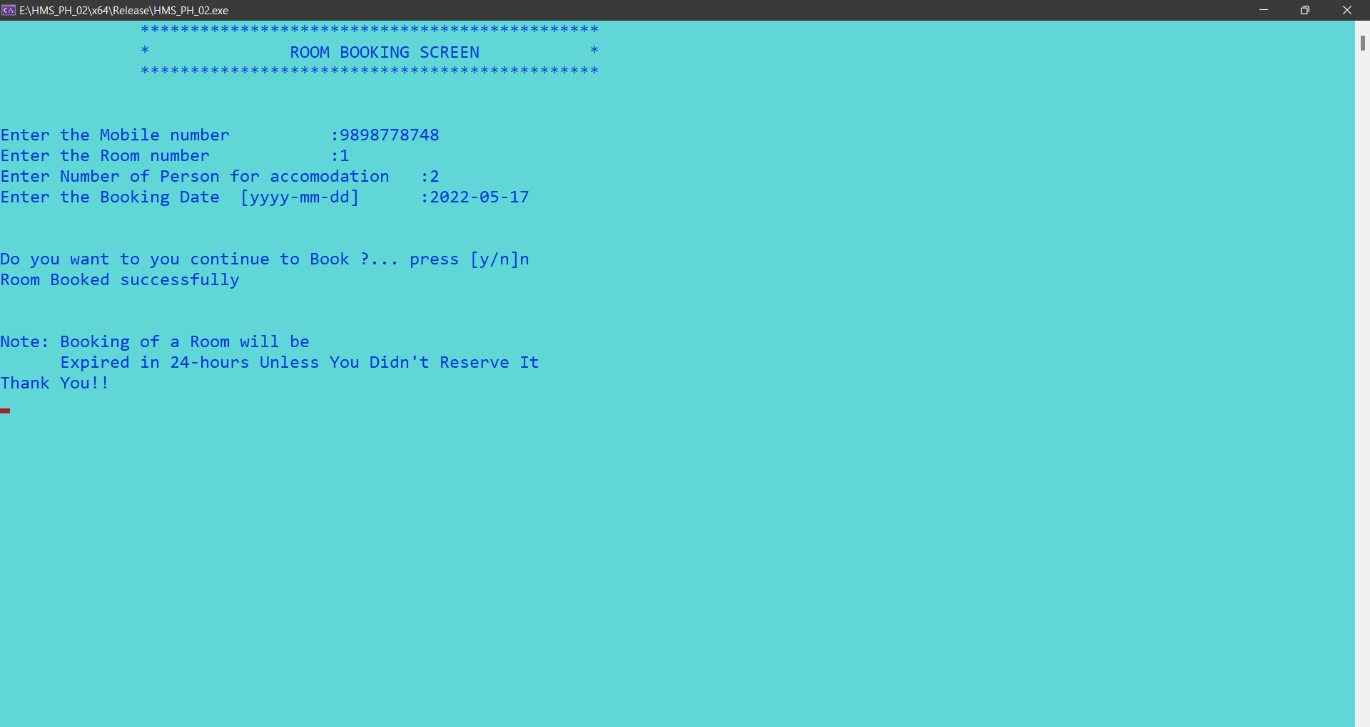

* The booked room will be canncelled or Expired in 24hrs unless the guest reservs it.

**In Guest-Info Table:**



**In Booking-Info Table:**



**In Hotel-Rooms-Info Table:**



**On Expiry of Booked Room (Pop-up Notification):**

The Guest gets a notification when the Booking of the room is Expired (Only once).

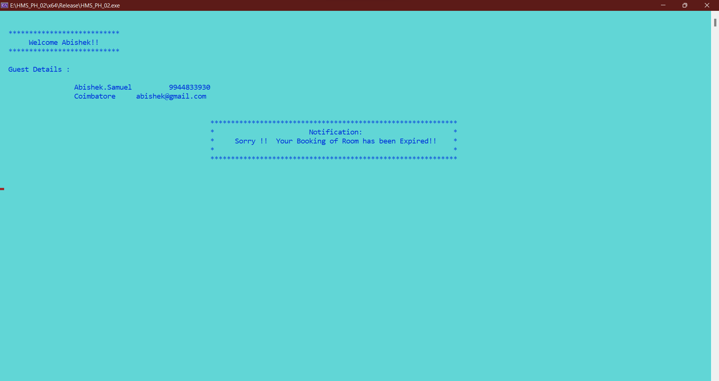

**In Booking Info Table:**



After the Cancellation of the Booked Room, it will be Available for Rebooking.

**Guest Room History:**

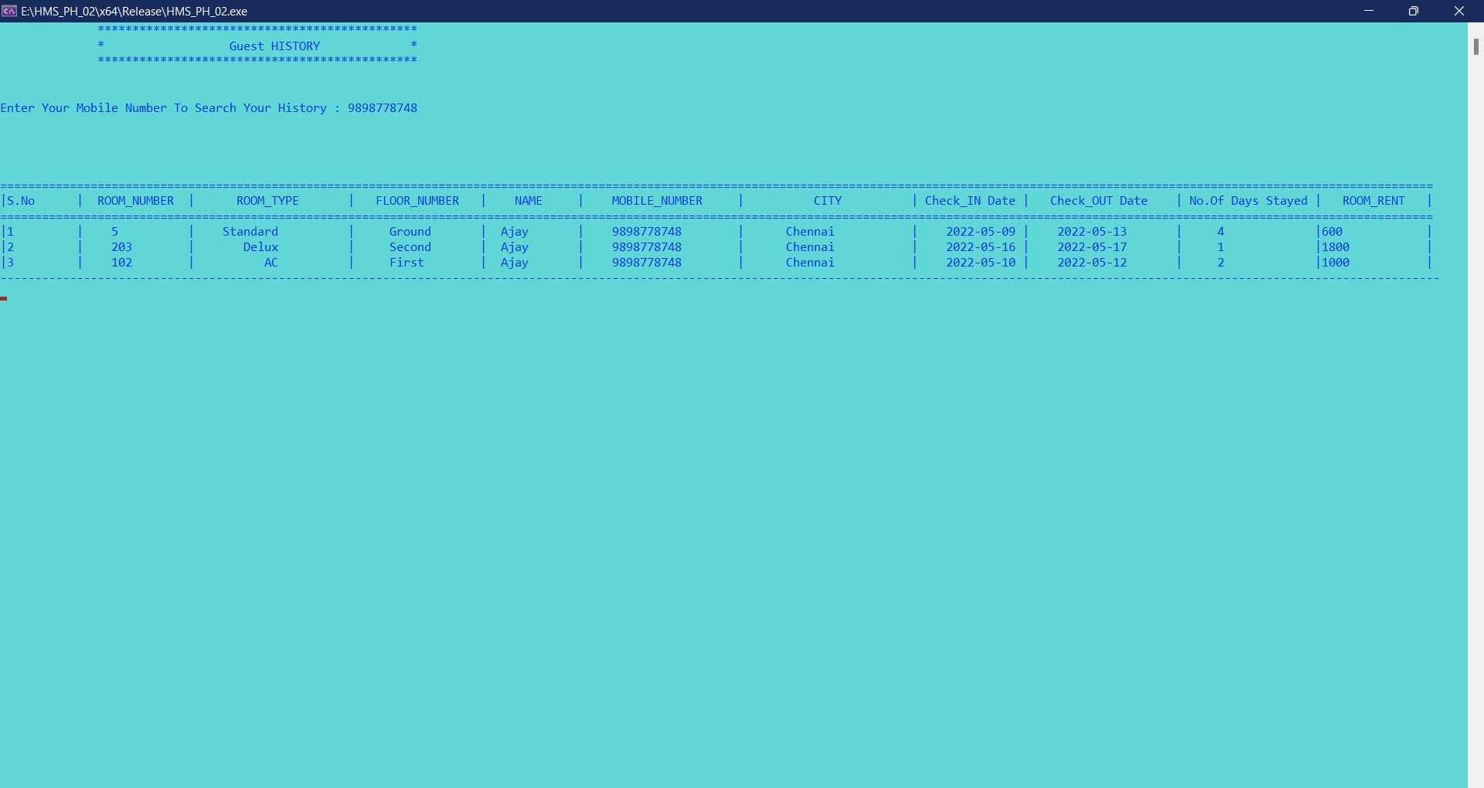

**Generic Search & combined search**

* Combined search
* Using Substring
* Case insensitive

**Example Screen 1: Combined search**

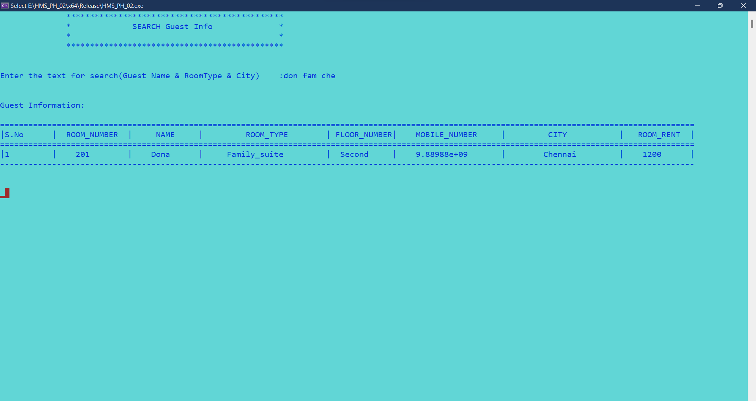

**Example Screen 2:** Using Substring & Case insensitive

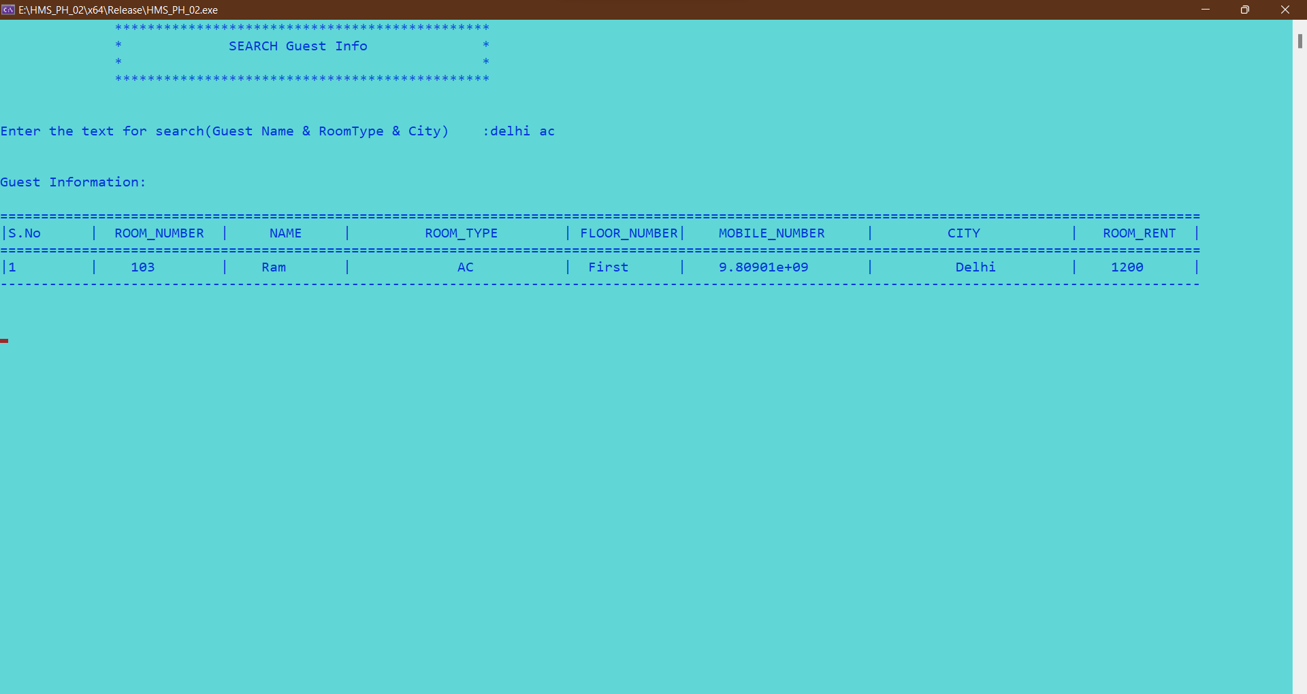

**Automatic Check-Out**



Current date : 2022-05-17

When the System date is changed to 2022-05-20:



The Check_out_date is updated in guest_info table. And the occupied status is changed to “no”.Where it is ready for rebooking.